Static Culling Custom targets

For StaticCulling, you can specify **any objects to cull**, and you can specify **any behavior for them**.

This scene prompts you to set up **culling for Particle System and Spot Light**.

To configure CullingTarget you need to do the following steps :

1. **Attach the StaticCullingSource component** to this object and select SourceType : Custom.
2. Set the **boundaries of this object**.

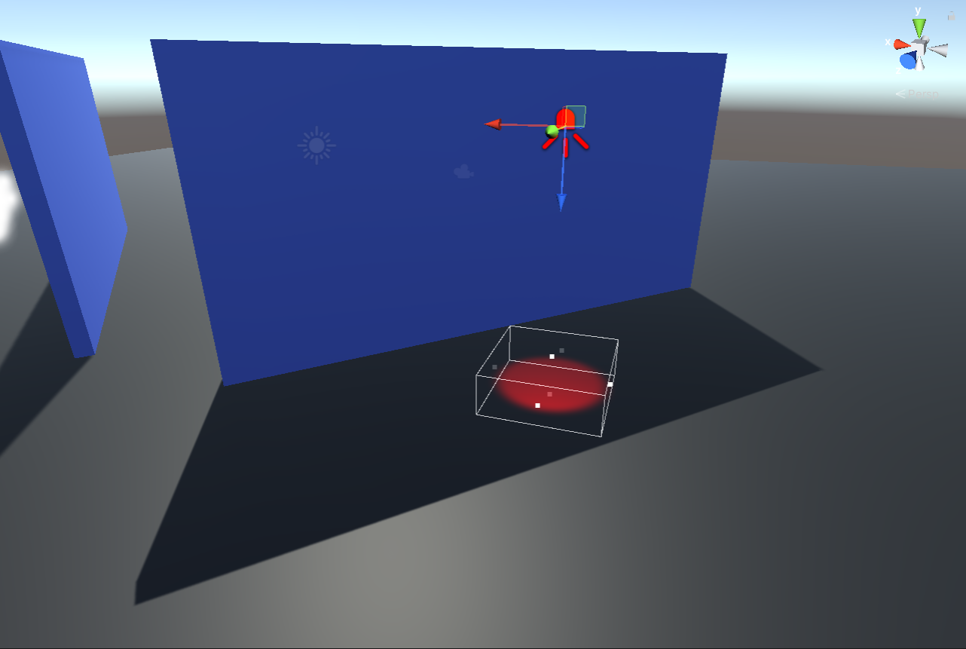

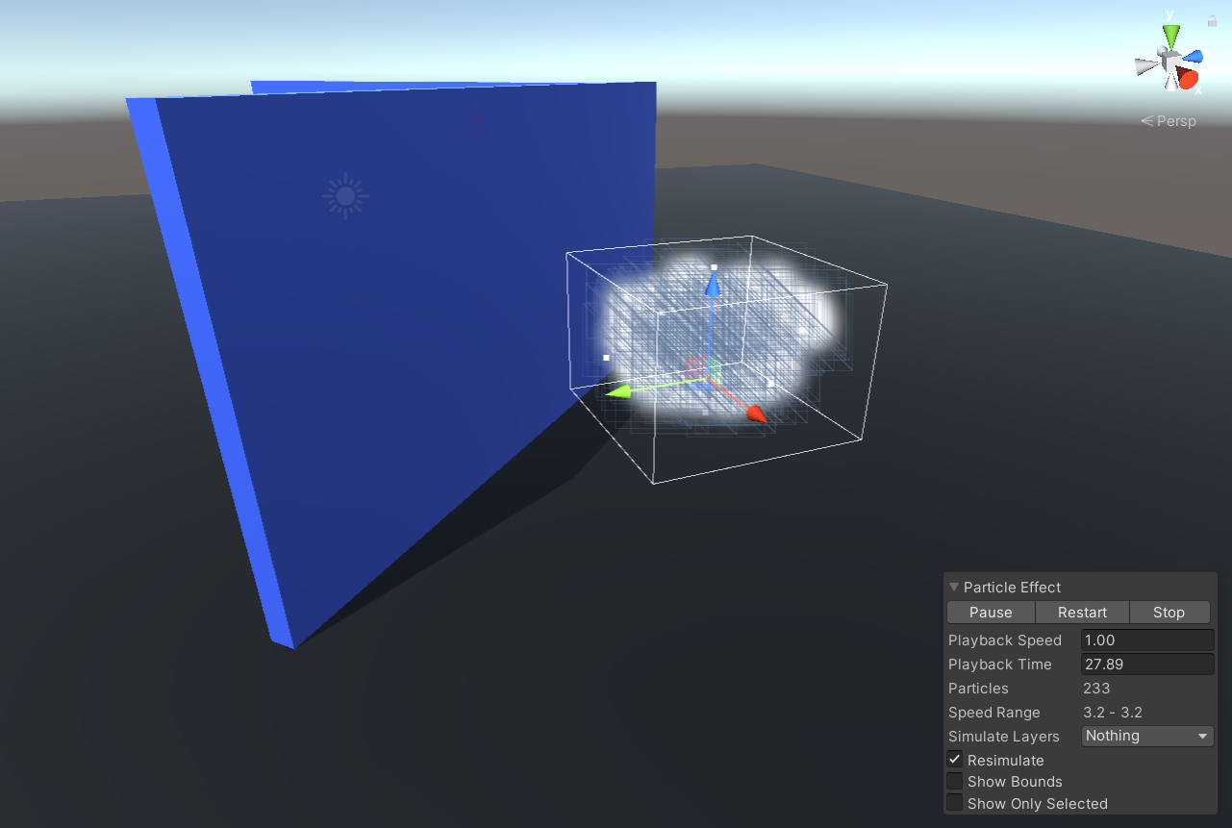

1. Set the **actions to be called** when the object is visible or not visible.

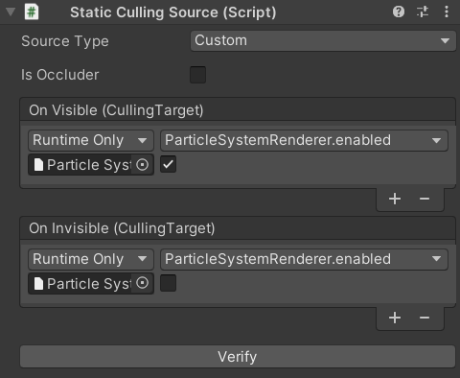

1. If the object can overlap other objects - **enable isOccluder** and use colliders to **set overlapping boundaries**.

Bake scene and look at results.